CTM-I Use Case

Batch Match

Version 0.1

Use Case Name | Batch Match
Actor | Market Operations, Operations, App Support
Pre-conditions /Assumptions | User has Browser and is aware of the http path to the application.  User has successfully logged into the CTM-I application.  User has the right role to see the menu options.
Post Conditions | None
Screenshot | 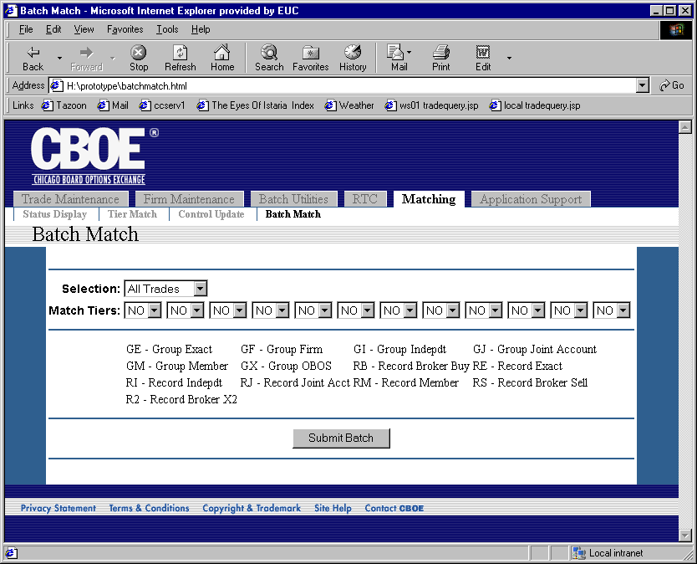
Flow of Events | - User selects “Batch Match” from the menu.  - The Batch Match screen is displayed.  - The following editable fields are displayed  - Selection – Choice of “All Trades” and “As Of Trades”  - Match Tiers – 12 selection fields that allow a user to select a matching process for each tier. They possible values are GE, GF, GI, GJ, GM, GX, RB, RE, RI, RJ, RM, RS and R2. The first option is NO in each case.  - The user presses the button “Submit Batch” to request the matching to be processed.  - The processing request is sent to CTM-R to process.  - The results of the CTM-R processing are displayed on the screen
Alternative Path | None

